European Family Summer Camp — Evidence-Based Founder Feasibility Report
Supplier discovery, two-city bake-off, economics, legal architecture, and paid-demand validation

Prepared from independently checkable public sources. No supplier inquiry, reservation, contract, booking, payment, or private-account access occurred.

Executive decision
Decision: CONDITIONAL BUILD
Do not select a city or collect customer money yet. Run a same-scope written-bid bake-off between the Cascais–Oeiras coast and Porto–Foz–Matosinhos. Porto is the current economic leader; Cascais is the current premium-brand leader. Launch only if legal, supplier, insurance, inventory and paid-demand gates all pass.

The business is plausible, but the proposed late-hours child program is not an off-the-shelf Portuguese camp product. Public camps establish operator supply, retail price anchors, ages and normal hours; none found publishes the proposed 21:30 weekday finish. That gap is the product differentiator and the central execution risk.
- Launch window: 4 July–1 August 2027; camp 5–30 July. The July start avoids relying on local primary-school availability before the official 30 June 2027 term end. [S05]
- MVP: 18 families, approximately 30 children, ages 6–12, four weeks.
- Child schedule: Monday–Thursday 13:30–21:30; Friday 13:30–18:30, with optional late Friday care priced separately.
- Operating model: Portuguese RNAVT organizer/merchant of record + IPDJ-registered camp operator + licensed/insured specialist vendors; U.S. brand owns positioning and community.
- Demand proof: Paid, fully refundable €250 priority reservations held by a compliant merchant of record. Free waitlists, likes, DMs and Instagram interest do not count.
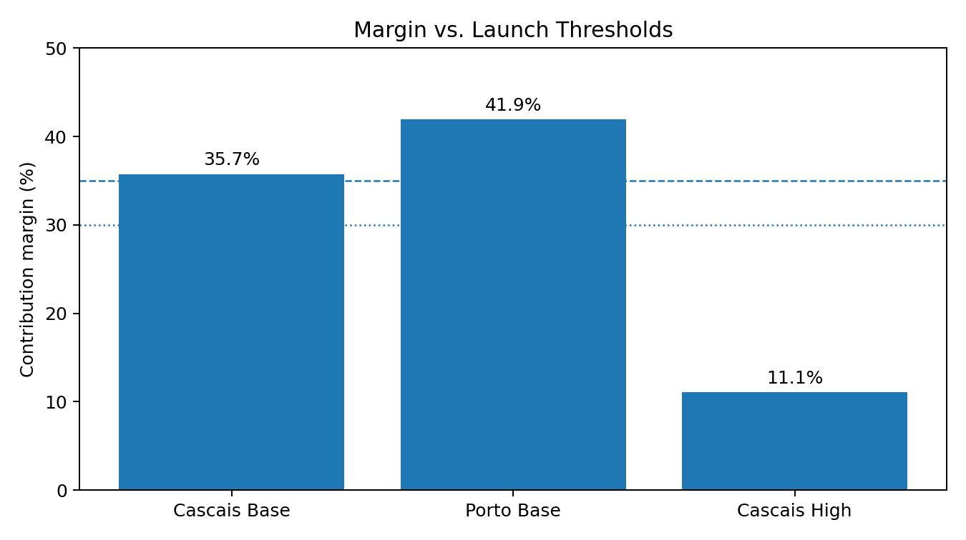

What changed after replacing assumptions with public evidence
Earlier premise | Public discovery finding | Revised decision
Cascais as predetermined launch city | Central/high-season Cascais retail housing can be far above viable unit economics; Porto has materially lower public 2BR anchors and several group-oriented operators. | Run Cascais and Porto as equal RFP tracks.
Late camp treated like a normal supplier quote | Public camps generally finish around 16:00–18:30. No public equivalent to 21:30 was found. | Price the late program bottom-up, then replace it with a custom IPDJ-operator bid.
Late-June start | Portuguese public preschool and first-cycle classes run through 30 June 2027. | Start 4 July; camp starts 5 July.
Single-apartment listings prove housing | They prove only price points, not 18 units, cluster geography, cancellation terms or July 2027 availability. | Require a unit-by-unit written inventory matrix.
Category interest proves demand | Market statistics establish a plausible audience, not willingness to pay €13.9k–€15.4k. | Use paid/refundable reservations and signed contracts.
Brand can accept deposits directly | Bundling housing, camp and activities is package-travel sensitive; U.S. seller-of-travel rules can also matter. | No money until fixed-scope Portuguese and U.S. legal review clears fund flow.

Evidence standard
Every material input in the financial model is labeled using the following hierarchy:
Class | Meaning | Permitted use
Observed | Official law/registry or a public supplier price, schedule, capacity statement or listing. | Can establish existence, legal requirements and a price anchor. It does not establish 2027 availability or negotiated group terms.
Derived | Arithmetic built from observed facts, such as staffing ratios, hours, public wages or scenario formulas. | May support a bounded planning range; must be replaced by a written bid before commitment.
Estimate | A reasoned range where no exact public analogue exists. | Only acceptable with a hard cap and an identified proof step.
Unknown | No reliable public evidence for the exact fact pattern. | Must be resolved before the applicable gate.

Critical limitation
Public discovery can identify capable-looking suppliers and defensible ranges. It cannot verify July 2027 inventory, commercial appetite, custom late-hours delivery, final insurance exclusions, tax treatment or contract enforceability.

Product definition
Element | Founding product
Dates | Arrival Sunday 4 July 2027; camp Monday 5 July–Friday 30 July; departure Sunday 1 August.
Families | 18 target; 15 signed-family absolute launch floor.
Children | Approximately 30; ages 6–12 only in year one.
Core hours | Mon–Thu 13:30–21:30; Fri 13:30–18:30.
Meals | Afternoon snack and dinner Mon–Thu; Friday snack and early meal/packed option subject to bid.
Housing | Independent 2BR family apartments with kitchen, reliable Wi-Fi, child-safe setup, utilities and cleaning included.
Parents | Optional coworking, two adult/community anchors weekly, local orientation, concierge channel and date-night add-on.
Families | Opening and closing events, one weekly family activity, curated weekend guides; major weekend excursions optional.
Customer promise | Live in Portugal for a month while maintaining an Eastern/Central-compatible or flexible U.S. work schedule.

Time-zone truth
Portugal summer time is five hours ahead of U.S. Eastern and eight hours ahead of Pacific. The proposed 13:30–21:30 local window corresponds to approximately 08:30–16:30 Eastern and 05:30–13:30 Pacific. A genuine 09:00–17:00 Pacific workday would require childcare to roughly 01:00 local time and is not a credible mass-market camp promise.
Defensible positioning
Do not advertise “work your normal U.S. day from Europe” without qualification. Advertise a product for Eastern/Central schedules, flexible founders, asynchronous professionals and families able to shift work earlier.

Destination bake-off
Destination | Weighted score | Role | Public-evidence interpretation
Cascais-Oeiras Coast | 90.0 | Primary premium RFP track | Strongest premium/partner ecosystem; housing cap is the critical risk.
Porto-Foz-Matosinhos | 88.7 | Primary value RFP track | Better economics; good public camp and furnished housing supply; premium positioning and clustered scale require bids.
Valencia | 82.1 | Plan C only | Excellent camps but one hour worse U.S. overlap and separate Spanish legal stack not yet researched to Portugal depth.
San Sebastian | 74.4 | Premium future cohort | Excellent local camp analogue and strong appeal; expensive constrained housing and weaker airport access.

The numerical score is a decision aid, not a fact. Cascais and Porto are close enough that supplier bids and paid price conversion should decide the launch city.

Track A — Cascais–Oeiras coast
- Strengths: Lisbon airport, coastal identity, international-school/camp supply, established family destination, premium brand fit.
- Weaknesses: High-season housing can destroy margin; central Cascais should not be the footprint assumption.
- Procurement zone: Cascais, Estoril, Monte Estoril, Parede, Carcavelos and Oeiras, subject to travel-time limits.
- Base housing cap: €3,650 average per 28-night family unit; at least 12 units at or below cap; remaining premium units no more than €4,200 absent repricing.
- Custom camp cap: €1,600 per child all-in for the required hours, meals, insurance and core activities.
Public evidence: [S13–S24, S57–S60, S71, S74, S85]

Track B — Porto–Foz–Matosinhos
- Strengths: Lower public furnished-housing anchors, credible university/English/surf camp supply, Atlantic coast, airport/metro access, stronger base economics.
- Weaknesses: Premium positioning and clustered family inventory need proof; camp and housing may be geographically dispersed.
- Procurement zone: Porto centre/Boavista/Foz, Matosinhos and Leça da Palmeira, with a transport plan.
- Base housing cap: €2,500 average per 28-night family unit.
- Custom camp cap: €1,500 per child all-in.
Public evidence: [S25–S34, S53, S62–S68, S70, S72–S73, S82–S84, S86]

Public housing discovery
Track | Public supplier/listing | Observed public evidence | What it proves / does not prove | Source
Cascais | BeGuest Cascais Inn | €2,200/month | Single unit; useful low anchor, not July group inventory | S57
Cascais | Parede family apartment | €2,700/30 days | Supports broader coast; single listing | S23
Cascais | Vila Bicuda T1 | €7,140/28 nights at 2026 high-season public retail | 79-villa scale signal; requires major discount | S20–S21
Cascais | Vila Bicuda T2 | €11,620/28 nights at 2026 high-season public retail | Not viable at retail | S20–S21
Cascais | NAMA Carcavelos | 45 planned residences | Potential single-site solution; opening and 2027 availability uncertain | S22
Cascais | Casa de Limão Parede | Three 2BR units; public €300/night | Micro-cluster only; retail far above cap | S74
Porto | Feel Corporate Housing Campanhã | €1,236 average/30 days | Low public anchor; date/scale not proven | S65
Porto | Boavista 2BR | €1,730 average/30 days | Supports Porto base range | S31
Porto | Uniplaces Bonfim 2BR | €1,960 published July 2026 monthly rate | Date-specific historical anchor | S66
Porto | Modern Cedofeita 2BR | €2,800 average/30 days | Upper public benchmark | S30
Porto | Vibrant Host | Eight apartments marketed for groups; public examples | High-priority RFP lead; family rate and inventory unknown | S72
Porto | Oporto Maison | Multiple serviced-apartment buildings; “from” rate public | Cluster lead; July quote required | S33–S34, S86

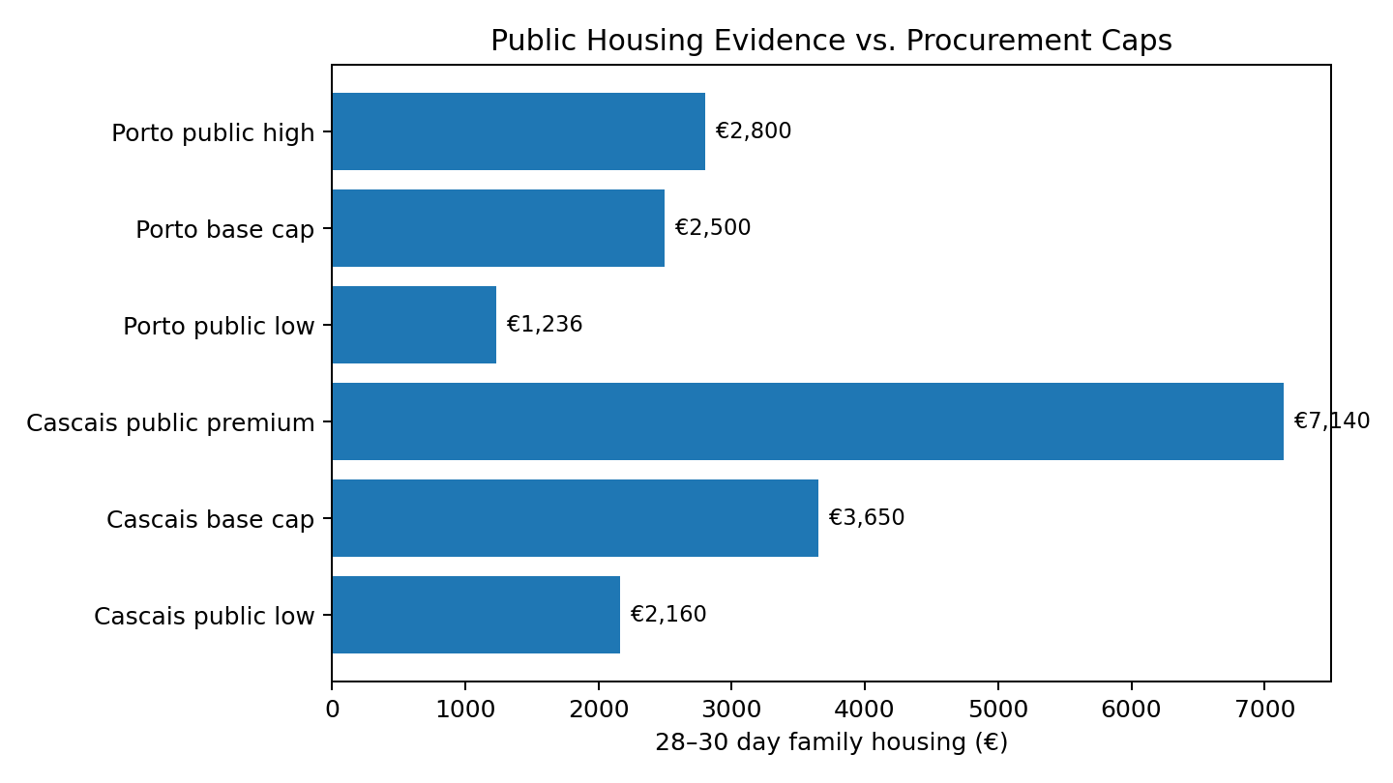
Housing conclusion
Porto has the stronger public cost evidence. Neither city has publicly demonstrated an 18-unit July 2027 cluster. A written inventory schedule—not a verbal capacity claim—must list every unit, bedrooms, occupancy, address, walking/transit time, tax, cleaning, utilities, cancellation and payment dates.

Public camp supplier discovery
Track | Supplier | Observed public product | Registry status | Interpretation | Source
Cascais | Camp Go | 08:30–17:30; €60/day | IPDJ 515/DRLVT | Credible operator; custom late bid required | S13,S71
Cascais | Carcavelos Tennis | 08:30–18:00; ~€950/4 weeks | IPDJ 413/DRLVT | Strong normal-hours anchor | S14,S71
Cascais | Prime School | 09:00–16:00; €300/week | SPRINGDOMAIN 410/DRLVT | International fit; no late product | S15,S71
Cascais | King’s Cascais | 08:30–16:30; €290/week | Legal organizer to confirm | Facility/brand option | S16
Cascais | Wave Riders | 09:30–17:30; €235/week | Specialist proof required | Surf component, not sole camp | S85
Porto | U.Porto CDUP | €155/week; food, insurance, sports kit included | IPDJ 253/DRNorte | Excellent low-cost benchmark; daily hours not public | S70,S83
Porto | Surfing Life | 09:00–18:00; €250/week with lunch; paid extensions public | IPDJ 25/DRNorte | High-priority custom-bid candidate | S70,S82
Porto | British Council | Arrival 09:00; pickup by 18:00; €195/week | Underlying organizer to document | English component; late extension required | S84
Porto | Juvigo Multi Camp listing | 08:30–18:30; from €190/week | Marketplace listing only | Useful schedule/price anchor | S68

Camp conclusion
Public normal-hours retail is roughly €620–€1,200 per child for four weeks, depending on supplier. The proposed late-hours all-in model is estimated at €1,450 Porto / €1,550 Cascais, with hard bid caps of €1,500 / €1,600. These figures are derived, not quotes.

Custom late-hours camp cost build
Cost block | Public evidence / derivation | Planning implication
Staffing | Portuguese law and IPDJ materials require a coordinator and age-based monitor ratios; mixed ages 6–12 create conservative staffing needs. [S01–S03] | Bid must show roster, ratios by activity, employment status and backup coverage.
Wages | Portugal’s 2026 minimum monthly wage is €920; qualified bilingual, late-shift staff should be budgeted above minimum. [S69] | Do not base service quality on minimum wage alone.
Employer cost | Public Portuguese Social Security guidance lists a 23.75% employer contribution benchmark. [S06] | Camp operator, not U.S. brand, should employ/manage monitors.
Meals | Four dinners/week plus snacks materially exceed normal day-camp catering. | Require menu, allergy process, food operator and per-child unit rate.
Insurance | Camp personal-accident and operator cover are mandatory/available; hazardous activities need endorsements. [S04,S79–S80] | Insurance must be included in camp bid with certificate and exclusions.
Late shift | No public operator publishes the 21:30 finish. | Custom premium and transport/safeguarding plan are unavoidable.

Legal and operating architecture
The public-law research indicates a package-sensitive product: accommodation, camp and other travel/tourist services are marketed together at an inclusive price. The exact classification, organizer identity, fund flow and tax treatment require fixed-scope Portuguese advice before any reservation payment.
Party | Recommended responsibility | Evidence/gate
U.S. brand company | Brand, marketing, customer insight, community design, partner QA and content. No direct customer fund collection before legal clearance. | U.S. seller-of-travel/privacy advice; Portuguese opinion on marketing/referral boundary.
Portuguese RNAVT organizer / merchant of record | Customer contract, package disclosures, funds, refunds, supplier contracts, assistance, tax/TAMS treatment and insolvency/RC framework. | Current RNAVT entry, liability policy, FGVT status and written MoR bid. [S75–S77]
IPDJ-registered camp operator | All child programming, staff, ratios, safeguarding, meals, venue, camp insurance, records and emergency operations. | Official registry record, prior communication evidence and complete custom bid. [S02,S70–S71]
Specialist vendors | Surf, transport and excursions under their own registrations, qualified staff and insurance. | Certificates, endorsements and contracts in organizer chain.
Housing suppliers | Licensed lodging, exact unit inventory, services, safety and cancellation terms. | Unit matrix and registration evidence.

Public evidence: [S01–S12, S75–S78, S87]

Public RNAVT discovery
Candidate | Observed registry/coverage evidence | Current limitation
Door Travel / D Travel | RNAVT 5243; public registry snapshot showed liability and FGVT information. | Coverage must be current for July 2027; no commercial quote.
Travel Store | RNAVT 2229; public registry snapshot. | Renewal timing and MoR appetite unverified.
Be In Travel | RNAVT 8116; public registry snapshot. | No quote or appointment.
Viagem à Vista | RNAVT 3840; public registry snapshot. | No quote or appointment.
Lisboa Sightseeing | Publicly markets DMC/group capability and an RNAVT number. | Official registry, insurance and exact legal entity must be reverified.

Official public benchmarks show an RNAVT registration fee and an initial guarantee-fund contribution, but those statutory costs do not establish a commercial organizer fee. The model retains an 8%–15% DMC/organizer range and a 10% base cap until same-scope bids arrive. [S75–S77]

Insurance evidence
Layer | Public evidence | Decision treatment
Camp personal accident | Mandatory framework and public historical pricing/coverage examples exist. [S04,S79] | Included in camp bid; policy schedule must cover dates, participants and activities.
Camp/operator liability | Public Portuguese tourist-animation/holiday-camp products exist. [S80] | Operator certificate and exclusions required.
RNAVT organizer liability/guarantee | Official registry framework requires liability/guarantee protections. [S75–S77] | Organizer must maintain cover through the cohort.
U.S. brand GL/E&O | No public quote matches U.S. marketing + minors + Portugal + package-sensitive product. | Model range €2,000–€6,000; must be replaced by bindable underwriting.
Surf, motor, food, cyber | Potential exclusions and separate vendor policies. | Each activity/vendor must be specifically scheduled or endorsed.

Insurance conclusion
The statutory camp policy itself is unlikely to be the major cost. The material unknown is cross-border brand/program liability, defense territory, U.S. claim exposure and hazardous-activity exclusions.

Economics
Scenario | Families | Revenue | Variable cost | Contribution margin | First-year result | Break-even families
Cascais low | 18 | €258,800 | €128,536 | 50.3% | €60,264 | 9.7
Cascais base | 18 | €263,400 | €169,273 | 35.7% | €15,627 | 15.0
Cascais high | 18 | €268,000 | €238,260 | 11.1% | –€70,260 | 60.5
Porto base | 18 | €237,600 | €138,000 | 41.9% | €23,100 | 13.8

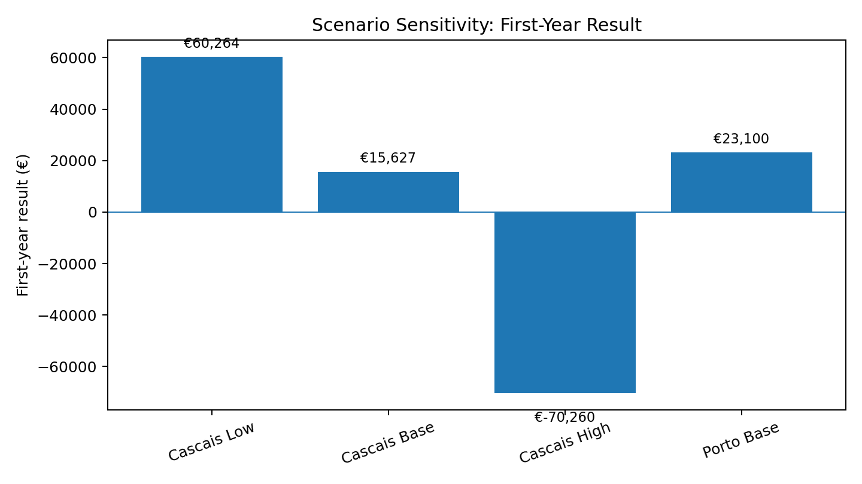
Base-case pricing is a market test, not validated demand: Cascais €13,100 for two adults + one child and €15,400 for a family of four; Porto €11,800 and €13,900 respectively. Airfare and most parent food are outside the program price.
- Cascais base: €263,400 revenue, 35.7% contribution margin, €15,627 first-year result and 15-family full first-year break-even.
- Porto base: €237,600 revenue, 41.9% contribution margin, €23,100 first-year result and 13.8-family full first-year break-even.
- High-cost failure: Cascais at €4,500 housing, €1,850 camp and 15% organizer fee collapses to an 11.1% contribution margin and a €70,260 first-year loss.
Economic rule
Do not “make it work” by hiding costs. If same-scope bids push contribution margin below 30%, or if full first-year break-even exceeds 15 signed families, stop or redesign.

Competitor and substitution pressure
Alternative | Public signal | Implication
Roam Collective | Public 2026 evidence indicates a five-week benchmark starting at €8,500 for one adult + one child, with additional-person pricing; Roam also reports a meaningful 2026 cohort. [S38–S39] | Proves category activity but not this product’s price conversion.
Boundless Life | Public 2027 Sintra summer pricing starts materially below the proposed family price and includes housing/education/community in the starting package. [S40] | The product must win on late hours, camp experience, community and housing—not merely Portugal.
DIY Porto/Cascais | Public housing + normal day camp can be substantially cheaper. | Customer pays for coordination, late hours, community, risk reduction and ready-made peers.
Local camps | Retail normal-hours programs are inexpensive. | Late-hours extension is the value driver and cost driver.

The key commercial question is not whether families like the idea. It is whether enough families will pay the proposed premium over a DIY month and over packaged alternatives.

Demand evidence and validation
- Addressable context: U.S. official statistics show a large population of families with children and working parents, and Census data show a large work-from-home population. [S41–S42]
- Pain evidence: Recent Pew research reports meaningful difficulty finding summer care among working parents who need care for ages 6–12. [S43]
- What this does not prove: It does not prove international travel intent, four-week availability, willingness to pay, or compatibility with shifted work hours.

Paid reservation protocol
- Complete the legal/MoR fund-flow gate before accepting any payment.
- Publish both city concepts with exact dates, hours, inclusions, exclusions, price and refund terms.
- Collect a €250 priority reservation that is fully refundable, credited to the program and held/refunded by the compliant merchant of record.
- Count only cleared, unique, active customer payments. Exclude staff/founder friends given special terms, duplicates, free signups, survey responses and social engagement.
- Required pace: 10 active paid reservations in 30 days; 20 in 60 days; 30–36 in 90 days.
- Select the city using written supplier economics plus paid conversion, not founder preference.
- Convert to signed program contracts; require at least 15 signed families by 31 January 2027.
Validation rule
A free waitlist may help build an audience, but it contributes zero to the launch gate.

Hard launch gates
Gate | Pass standard | Deadline logic
Portuguese legal/tax | Fixed written opinion for package classification, organizer, TAMS/VAT, camp boundary, employment/PE, lodging, minors/privacy and consumer terms. | Before marketing a paid reservation
U.S. legal | Written treatment of CA/FL/WA seller-of-travel exposure, refundable reservation collection, privacy and marketing/referral structure. | Before taking money
RNAVT/MoR | Current registry, RC policy, FGVT, MoR function, English customer terms, refund SLA and fee ≤10% absent repricing. | Before reservation launch
Camp | IPDJ registration; custom full-scope bid; staff/ratios; safeguarding; venue; meals; insurance; transport; emergency plan. | Before selecting city
Housing Cascais | 18 units, average ≤€3,650; exact matrix; acceptable clustering/cancellation. | Before material commitment
Housing Porto | 18 units, average ≤€2,500; exact matrix; acceptable clustering/cancellation. | Before material commitment
Insurance | Bindable cross-border brand/program terms and all vendor certificates/endorsements. | Before sale
Economics | Contribution margin ≥35% target, 30% absolute floor; full first-year break-even ≤15 families. | After bid normalization
Paid demand | 10/30d; 20/60d; 30–36/90d; ≥15 signed by 31 Jan 2027. | Before nonrefundable inventory
Working capital | Nonrefundable supplier exposure fully covered by collected, legally usable customer capital plus reserve. | At every commitment

Recommended execution sequence
- Issue identical RFPs to the Cascais and Porto camp, housing and RNAVT shortlists.
- Commission fixed-scope Portuguese legal/tax review using the included legal brief; in parallel commission U.S. seller-of-travel/privacy review.
- Normalize written bids into the workbook. Reject incomplete supplier responses rather than filling gaps with optimism.
- Obtain bindable insurance indications for the exact fact pattern and activity set.
- Run a legal-compliant paid/reservable two-city price test.
- Choose the city only if both its supplier economics and its paid conversion pass.
- Secure conditional inventory with staged deposits tied to signed-family thresholds.
- Reach 15 signed families by 31 January 2027 or stop.
- Run final supplier verification, safeguarding, emergency and customer-onboarding work.
The free work now complete is public discovery: supplier names, public prices, official registration evidence, public law/regulator sources, model ranges and fail gates. The next evidence is inherently non-public and must be generated through written bids, fixed-scope advice, underwriting and paid reservations.

Founder decision
Current recommendation
Proceed to procurement and legal validation, not to launch. Porto is the first economic choice if it can support a coherent family cluster and premium customer experience. Cascais remains viable only if coastal inventory averages at or below €3,650 and the late camp stays at or below €1,600 per child. Select neither if paid demand or legal/safety gates fail.

Appendix A — Key model inputs
Category | Input | Low | Base | High | Evidence class | Source
Cohort design | Families | 18 | 18 | 18 | Design choice | Founder design
Cohort design | Children | 28 | 30 | 32 | Estimate | Derived planning range
Pricing - Cascais | Base family price (2 adults + 1 child) | 13100 | 13100 | 13100 | Test price | Pricing hypothesis informed by Roam benchmark [S38-S39]
Pricing - Cascais | Additional child price | 2300 | 2300 | 2300 | Test price | Derived
Pricing - Porto | Base family price (2 adults + 1 child) | 11800 | 11800 | 11800 | Test price | Derived
Pricing - Porto | Additional child price | 2100 | 2100 | 2100 | Test price | Derived
Housing - Cascais coast | 28-night family unit | 3000 | 3600 | 4500 | Estimate from public inventory | S20-S24,S57-S60,S74
Housing - Porto | 28-night family unit | 1900 | 2400 | 3200 | Estimate from public inventory | S29-S34,S62-S66,S72-S73,S86
Camp - Cascais coast | 4-week normal-hours public retail | 486 | 1000 | 1200 | Observed range | S13-S19
Camp - Porto | 4-week normal-hours public retail | 620 | 780 | 1000 | Observed range | S25-S28,S70,S82-S84
Camp - Cascais coast | Custom late-hours camp all-in | 1350 | 1550 | 1850 | Derived estimate | S01-S06 and supplier range S13-S19
Camp - Porto | Custom late-hours camp all-in | 1250 | 1450 | 1750 | Derived estimate | S01-S06 and S25-S28
Organizer/DMC | Fee on supplier spend | 0.08 | 0.1 | 0.15 | Market estimate | S49-S52 and market benchmark
Payment | Blended processing cost | 0.01 | 0.024 | 0.033 | Derived from public pricing | S44-S45
Tax reserve | VAT/TAMS reserve | 0.0075 | 0.015 | 0.03 | Provisional reserve | S07-S08
Customer acquisition | CAC | 600 | 900 | 1500 | Test assumption | Requires paid campaign
Community | Events/programming | 350 | 490 | 700 | Estimate from public activities | Municipal and supplier discovery
Transfers | Airport transfer allocation | 120 | 150 | 180 | Estimate from public retail | S48
Transit | Local transit allocation | 50 | 60 | 80 | Observed/estimated | S47
Legal | Fixed-scope Portuguese legal/tax review | 3075 | 7500 | 14760 | Derived estimate | S81 plus fixed-scope quote required
Legal | U.S. seller-of-travel/privacy review | 3000 | 4000 | 6000 | Estimate | S10-S12
Insurance | Brand/program insurance allocation | 2000 | 4000 | 6000 | Estimate | S04,S79-S80 + written underwriting

Appendix B — Public source register
ID | Category | Source | Type
S01 | Portugal camp law | Decree-Law 32/2011 - holiday camp organizer regime | Official law
S02 | Portugal camp registration | IPDJ - Registration of Holiday Camp Organizers | Official regulator
S03 | Portugal camp staffing | IPDJ - Ferias em Movimento program and staffing support benchmarks | Official regulator
S04 | Portugal camp insurance | Portaria 629/2004 - mandatory camp insurance minimums | Official law
S05 | Portugal school calendar | Despacho 8368/2024 - school calendars through 2027-28 | Official law
S06 | Portugal employer costs | Portuguese Social Security - employer contribution 23.75% | Official regulator
S07 | EU tourism rules | Your Europe - tourism business, package travel and VAT margin scheme | Official EU
S08 | Portugal package travel | Decree-Law 17/2018 - package travel and linked travel arrangements | Official law
S09 | EU package travel | European Commission - Package Travel Directive | Official EU
S10 | California seller of travel | California Attorney General - Seller of Travel | Official regulator
S11 | Florida seller of travel | Florida FDACS - Sellers of Travel | Official regulator
S12 | Washington seller of travel | Washington Department of Licensing - Sellers of Travel | Official regulator
S13 | Cascais camp supplier | Camp Go 2026 at IPS Cascais | Supplier
S14 | Cascais camp supplier | Carcavelos Tennis School - Summer Camp | Supplier
S15 | Cascais camp supplier | Prime School Summer Camp 2026 | Supplier
S16 | Cascais camp supplier | King's College School Cascais Summer Camp | Supplier
S17 | Cascais camp supplier | Shaka Surf Camp Cascais | Supplier
S18 | Cascais camp supplier | Anima Park ATL and holiday camps | Supplier
S19 | Cascais camp supplier | Oeiras Sports Holiday Program | Municipal program
S20 | Cascais housing | Vila Bicuda official site | Supplier
S21 | Cascais housing | Vila Bicuda public 2026 high-season retail rate listing | Public reseller
S22 | Cascais housing | NAMA House Carcavelos - 45 serviced residences | Supplier/development
S23 | Cascais housing | Flatio Parede furnished family apartment | Public listing
S24 | Cascais housing | Portugal Portfolio Cascais coast inventory | Property manager
S25 | Porto camp supplier | British Council Porto Summer Courses 2026 | Supplier
S26 | Porto camp supplier | University of Porto Sports Holiday Camp 2026 | University supplier
S27 | Porto camp supplier | Surfing Life Club Porto Kids Camps 2026 | Supplier
S28 | Porto camp supplier | CCD Porto Holiday Camps 2026 | Supplier
S29 | Porto housing | Flatio Feel Corporate Housing Marques II | Public listing
S30 | Porto housing | Flatio Modern 2BR Cedofeita | Public listing
S31 | Porto housing | Flatio BoaVista 2BR apartment | Public listing
S32 | Porto housing | Flatio VIVA Republica 2BR serviced apartment | Public listing
S33 | Porto housing | Oporto Maison serviced apartments | Supplier
S34 | Porto housing | Oporto Maison Alves da Veiga apartments | Supplier
S35 | Valencia camp supplier | American School of Valencia Summer Program 2026 | Supplier
S36 | Valencia camp supplier | Valencia Tennis Academy Summer Camp 2026 | Supplier
S37 | Valencia camp supplier | Valencia CF Summer Camp 2026 | Supplier
S38 | Competitor | Roam Collective official site | Competitor
S39 | Competitor | Roam / ilo published terms | Competitor terms
S40 | Competitor | Boundless Life public pricing | Competitor
S41 | Demand | BLS - employment in families with children, 2025 | Official statistics
S42 | Demand | U.S. Census - work from home inequalities | Official statistics
S43 | Demand | Pew - parents' summer childcare difficulty, 2026 | Research
S44 | Payments | Stripe Portugal pricing | Supplier
S45 | Payments | Stripe U.S. pricing | Supplier
S46 | Coworking | Cowork Cascais pricing | Supplier
S47 | Transit | MobiCascais fares and passes | Municipal supplier
S48 | Transfers | Airport City Transfer Cascais pricing | Supplier
S49 | RNAVT/DMC | Lisboa Sightseeing DMC and group services | Supplier
S50 | RNAVT/DMC | Portugal Travel Concierge white-label DMC | Supplier
S51 | RNAVT/DMC | LIMITS DMC Cascais | Supplier
S52 | RNAVT/DMC | Cititravel Portugal DMC | Supplier
S53 | Legal pricing | CoreLegal public business legal retainer pricing | Legal supplier
S54 | Insurance discovery | Ponto Seguro holiday camp insurance | Insurance broker
S55 | Insurance discovery | Generali holiday camp / ATL insurance | Insurer
S56 | Insurance discovery | BIS Allianz tourist animation liability insurance | Broker
S57 | Cascais housing | BeGuest Cascais Inn 2BR monthly listing | Public listing
S58 | Cascais housing | Flatio Estoril Beach Flower 2BR | Public listing
S59 | Cascais housing | Flatio Monte Estoril 2BR with pool | Public listing
S60 | Cascais housing | Flatio Historical Cascais 2BR | Public listing
S61 | RNAVT registry | Official RNAVT 5243 - Door Travel / D Travel | Official registry
S62 | RNAVT registry | Official RNAVT 2229 - Travel Store | Official registry
S63 | RNAVT registry | Official RNAVT 8116 - Be In Travel | Official registry
S64 | RNAVT registry | Official RNAVT 3840 - Viagem a Vista | Official registry
S65 | Porto housing | Flatio Campanha 2BR family apartment | Public listing
S66 | Porto housing | Uniplaces Bonfim 2BR 2026 monthly listing | Public listing
S67 | Valencia camp supplier | Futedu full-day soccer camp | Supplier
S68 | Porto camp supplier | Juvigo Porto Multi Camp | Marketplace listing
S69 | Portugal wage | Portuguese Government - minimum wage rises to €920 in 2026 | Official government
S70 | Portugal camp registry | IPDJ - Registered holiday camp organizers, North region | Official regulator PDF
S71 | Portugal camp registry | IPDJ - Registered holiday camp organizers, Lisbon and Tagus Valley | Official regulator PDF
S72 | Porto housing | Vibrant Host Solutions - group apartment inventory | Property manager
S73 | Porto housing | Porto Touristic Apartments - registered apartment portfolio | Property manager
S74 | Cascais housing | Casa de Limão - Parede apartment inventory | Property manager
S75 | RNAVT registry | Turismo de Portugal - National Tourism Registry | Official registry
S76 | RNAVT registration | ePortugal - RNAVT registration requirements and fee | Official government
S77 | RNAVT fund | Turismo de Portugal - Travel and Tourism Guarantee Fund contribution | Official government
S78 | EU package travel | Directive (EU) 2026/1024 amending package travel rules | Official EU law
S79 | Camp insurance | Ponto Seguro - public holiday-camp personal accident price example | Broker historical price
S80 | Tourist animation insurance | BIS - tourist animation insurance public pricing | Broker public price
S81 | Legal market pricing | Fixando Portugal - legal services public price guide | Marketplace price guide
S82 | Porto camp supplier | Surfing Life Club - schools and youth programs | Supplier
S83 | Porto camp supplier | University of Porto CDUP 2026 summer sports camp | University supplier
S84 | Porto camp supplier | British Council Portugal - Porto English summer courses | Supplier
S85 | Cascais camp supplier | Cascais Wave Riders surf clinics | Supplier
S86 | Porto housing | Oporto Maison Entreparedes apartments | Property manager
S87 | EU package travel | Your Europe business guidance - package travel | Official EU guidance

